Dominion Online Software Design Document

April 2018

Version 1.1

*UMUC*

**Document Revisions**

|  |  |  |
| --- | --- | --- |
| **Date** | **Version Number** | **Document Changes** |
| 04/03/2018 | 1.0 | Initial Draft |
| 05/05/2018 | 1.1 | Updated Definitions and User Interface |
|  |  |  |
|  |  |  |
|  |  |  |
|  |  |  |
|  |  |  |
|  |  |  |
|  |  |  |

**Table of Contents**

1 Introduction 4

1.1 Overview 4

1.2 Project Summary 4

1.3 Assumptions and Constraints 4

1.4 Project Deliverables 4

2 Definitions 4

2.1 Description of Objects - Server 4

2.2 Description of Objects - Database 5

3 Project Organization 6

4 Methods, Tools & Techniques 6

5 Data Management 6

5.1 Server Files 6

5.2 Client Files 6

6 User Interface 7

4 Methods, Tools & Techniques 7

# Introduction

## Overview

The purpose of this system is to provide a platform, in web page format, accessible by multiple device types, in which players can connect with one another and play games of Dominion.

## Project Summary

Our goal is to create a platform-independent online presence through which multiple players may play the deck building strategy game "Dominion" online with others. Players should have the ability to create an account, login with an existing account, sign up for an online match with other players pending in queue, and track the history of their games.

## Assumptions and Constraints

It is assumed that potential players have sufficient hardware at their disposal to run the software and connect to a website. This should include an internet connection and browser software. Potential players should also have a valid email address in order to reset account credentials.

## Project Deliverables

* Software package for the user client
* User guide
* Server application for client software connections
* Database backend to support the server application

# Definitions

## Description of Objects - Server

Objects involved in the Dominion Online project will appear in the source code for the website (server backend) and client.

Object classes to be implemented in TypeScript:

Game {

Player[] players

Card[] trash

Card[][] supply

Player currentPlayer

}

Player

{

string name

int score

Card[] deck

Card[] discard

Card[] hand

int coins

int actions

int buys

}

Card

{

string name

int cost

string type (‘Action’, ‘Treasure’, ‘Victory’)

string description

soundFile file

int value

}

## Description of Objects - Database

Tables and attributes involved in the Dominion Online project to appear in the back-end database.

Player

{

varchar(55) username PK

varchar(32) password (in md5 hash format)

varchar(255) email

varchar(55) firstname

varchar(55) lastname

varchar(255) fullname

varchar(55) location

date joindate

}

PastSessions

{

varchar(55) players FK <multi valued field>

varchar(55) winner FK

}

Cards

{

string name PK

varchar(55) type

int cost

}

# Project Organization

See the Project Management Plan for details on team breakdown, milestones, roles and organization: <https://docs.google.com/document/d/1HsZwZIisRAXqXq80eQlqRbTNdulHsE1aEqqgbyi0RRE/edit>

# Methods, Tools & Techniques

The project client and server back end will be written in TypeScript and Python 3.6, on a Debian 9.4 server. Databases will be developed concurrently in MS Access 2013 and Oracle 12c for compatibility. Documentation is maintained in MS Office 2013, Github, and Google Docs.

The project will be considered complete when all development requirements have been met. Development is expected to take 8 weeks, to include testing and implementation.

# Data Management

This section describes data storage and usage within the system.

## Server Files

* Executable code
* Configuration files
* Static assets (all game and website assets, including artwork, sound, client-side scripts, templates, and stylesheets)
* Database files (oracle data directory)

## Client Files

* The client will not have to provide any files in order to use the web application

# User Interface

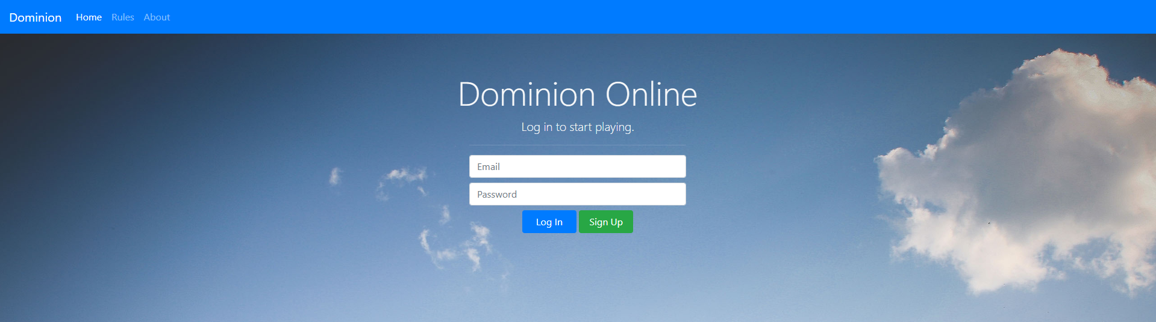

Home Page (Login/Registration)

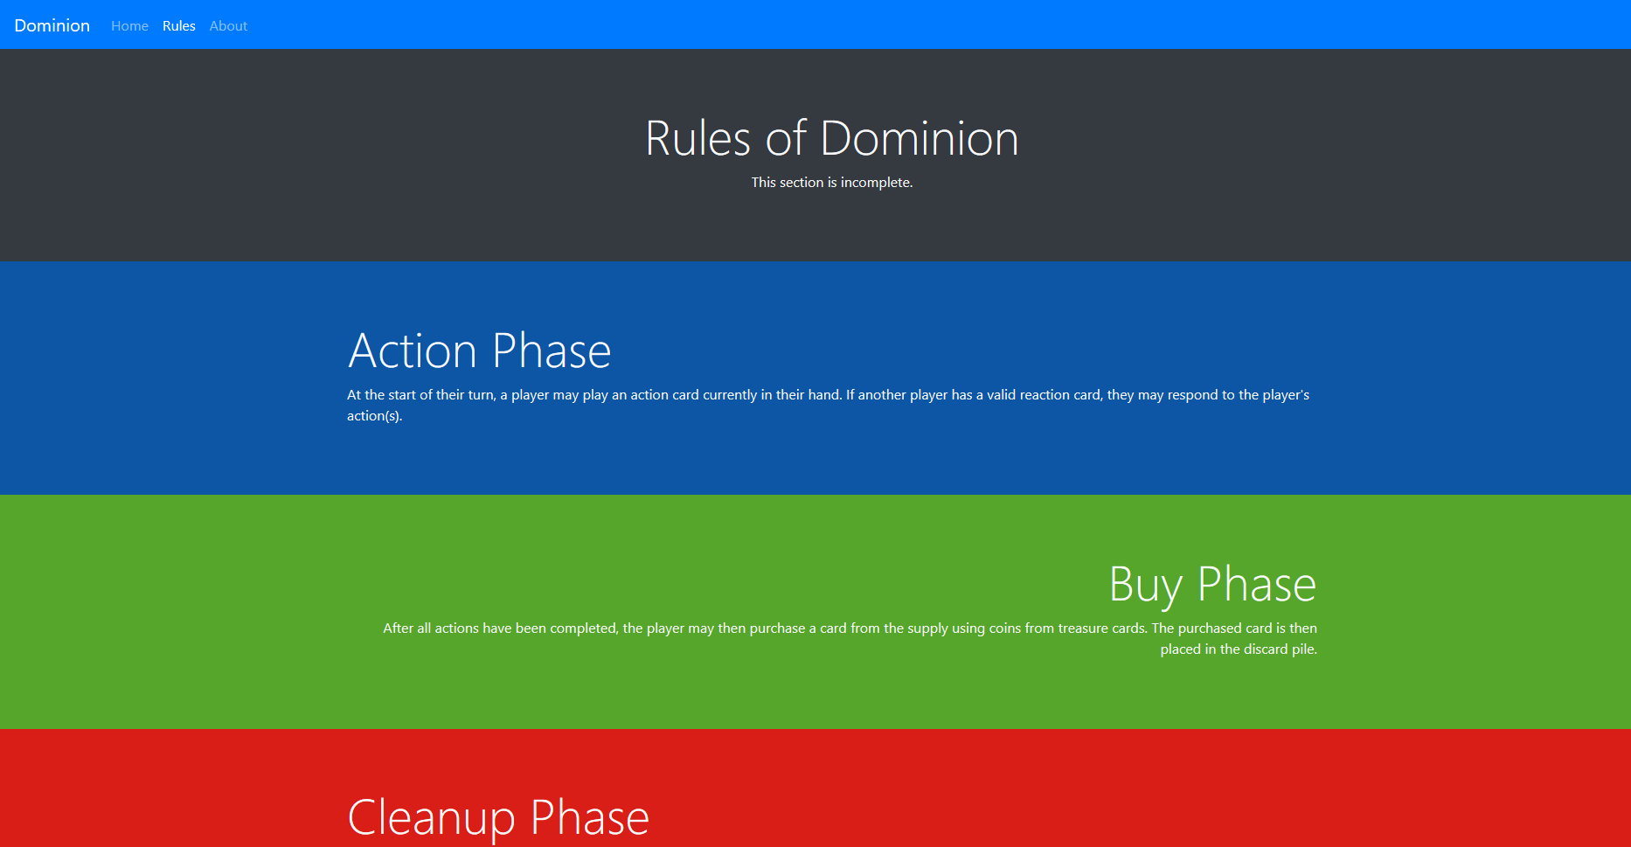

Rules Page



About Page

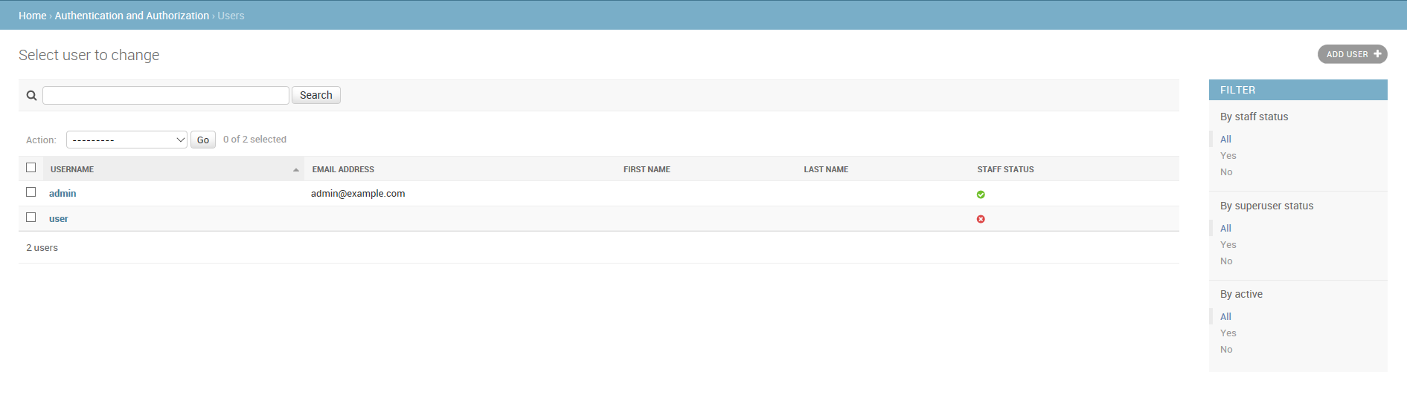

User Administration Page (once logged in, non-admin users may only edit their own profile)

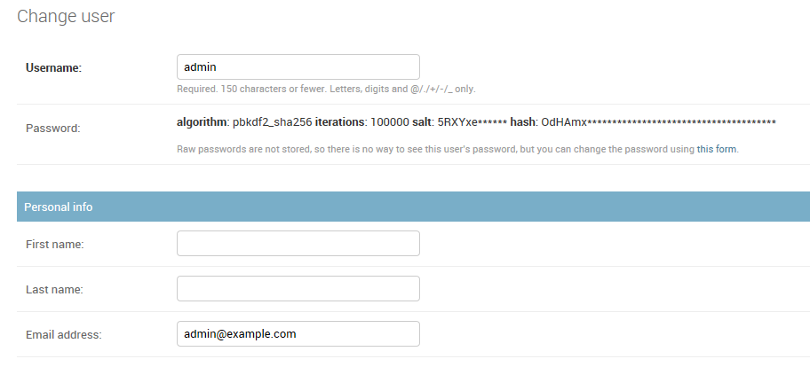

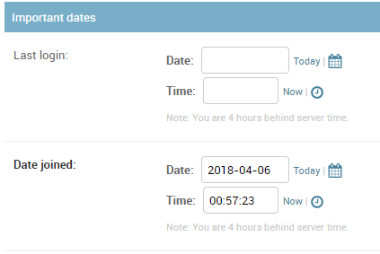

User Profile Page

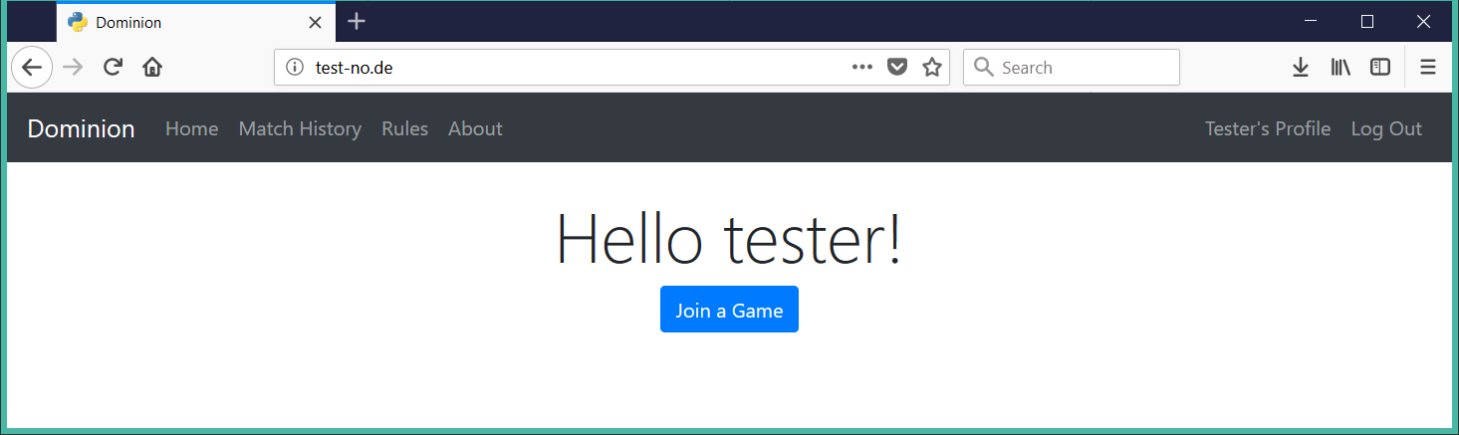

Main Page

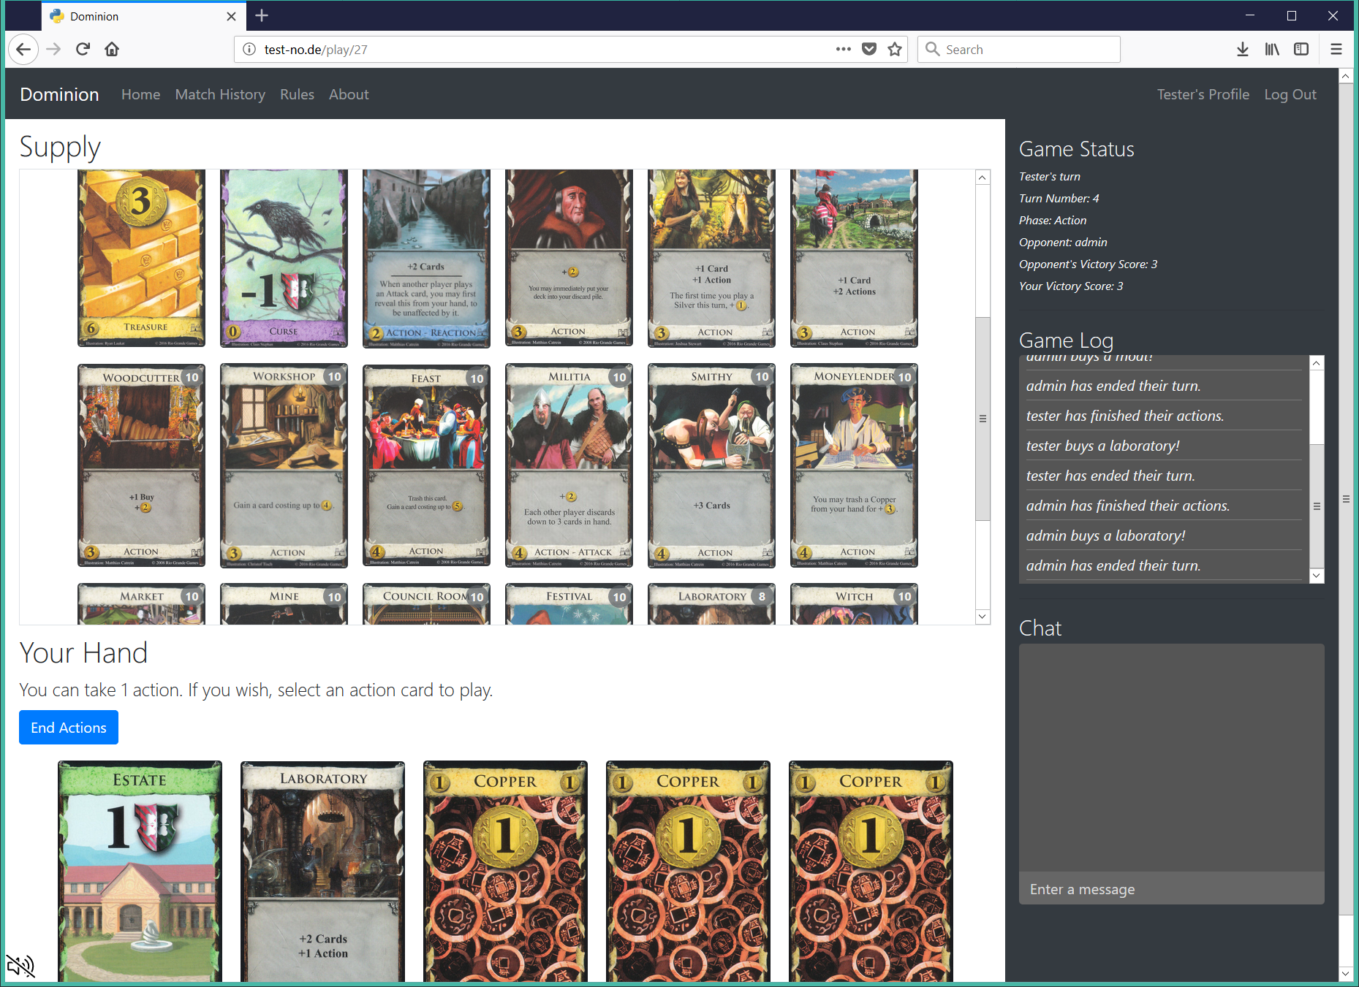

Game Page

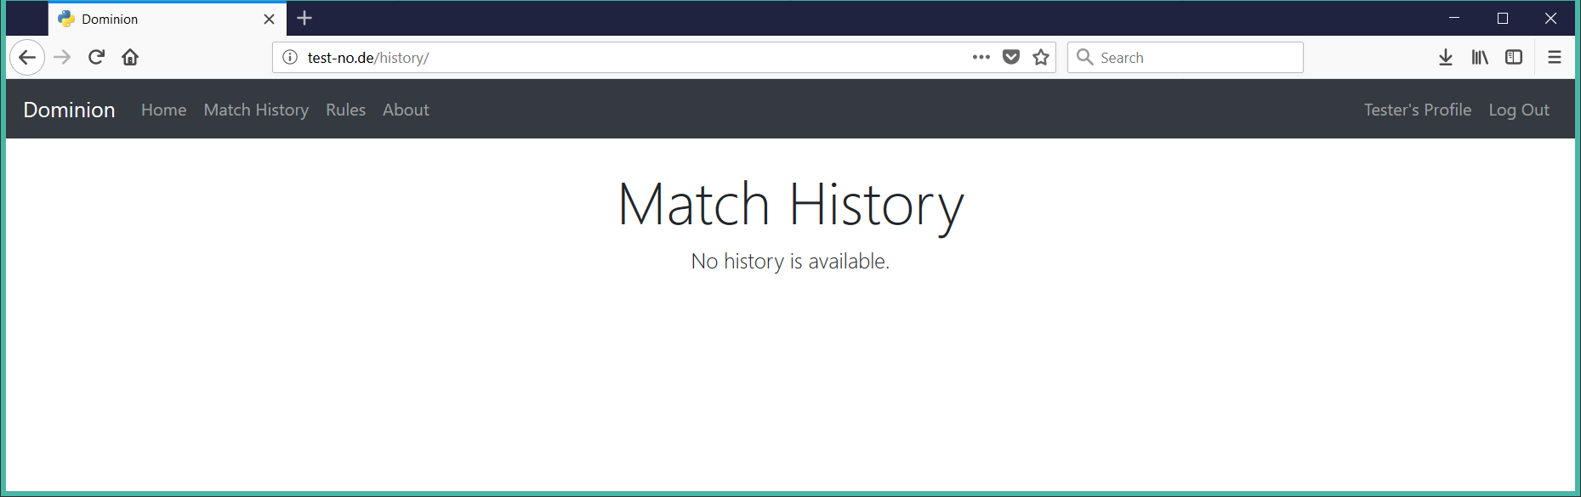

Match History